PRACTICAL- 17
Develop a program to demonstrate abstract methods and classes in java

// Abstract class Animal
abstract class Animal {
// Abstract method (does not have a body)
public abstract void sound();

// Regular method (can have a body)
public void sleep() {
System.out.println("This animal is sleeping.");
}
}

// Dog class inherits from Animal and provides implementation for sound()
class Dog extends Animal {
@Override
public void sound() {
System.out.println("The dog barks.");
}
}

// Cat class inherits from Animal and provides implementation for sound()
class Cat extends Animal {
@Override
public void sound() {
System.out.println("The cat meows.");
}
}

// Main class to test the functionality
public class AbstractClassExample {
public static void main(String[] args) {
// Create objects of Dog and Cat (both are subclasses of Animal)
Animal dog = new Dog();
Animal cat = new Cat();

// Call the sound() method (abstract method implemented in subclasses)
dog.sound(); // Output: The dog barks.
cat.sound(); // Output: The cat meows.

// Call the sleep() method (regular method from the abstract class)
dog.sleep(); // Output: This animal is sleeping.
cat.sleep(); // Output: This animal is sleeping.
}
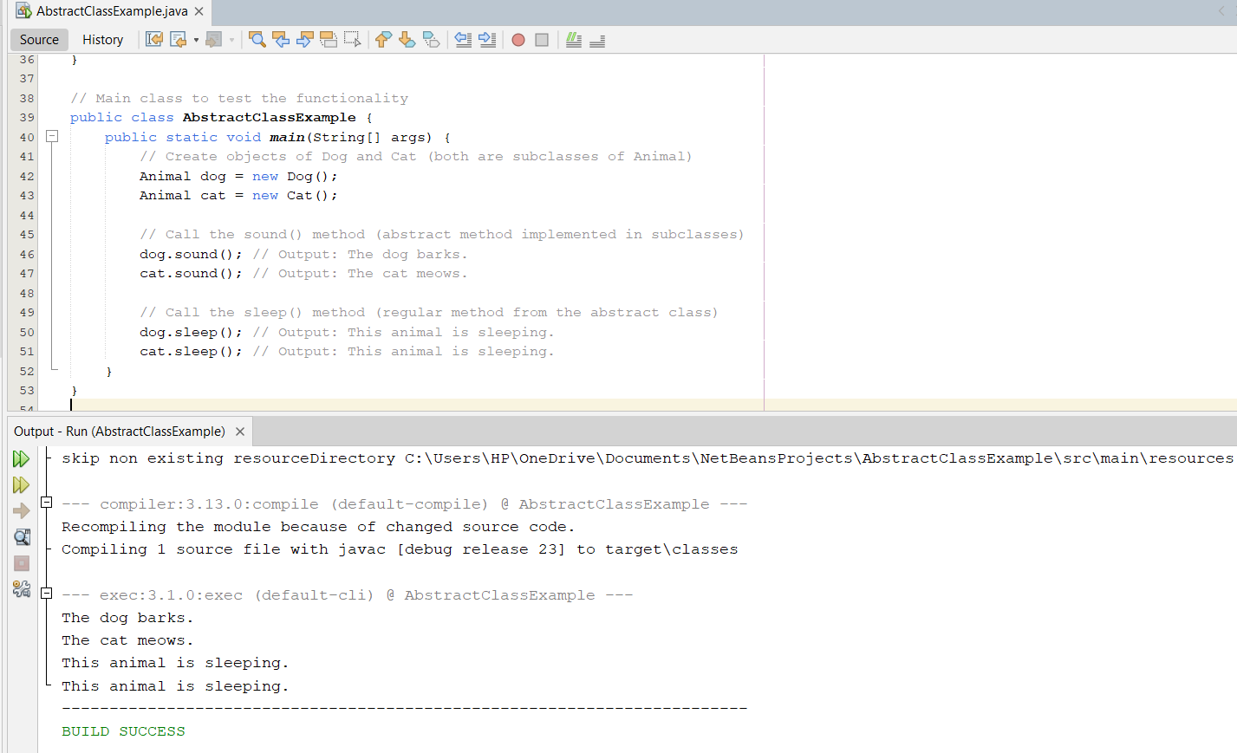
}

PRACTICAL-18

Develop a program in java to demonstrate string class and it’s methods.

public class StringDemo {
public static void main(String[] args) {

// 1. Creating Strings
String str1 = "Hello, World!";
String str2 = new String("Java Programming");

// 2. Length of the String
System.out.println("Length of str1: " + str1.length()); // Output: 13
System.out.println("Length of str2: " + str2.length()); // Output: 16

// 3. Convert to Uppercase and Lowercase
System.out.println("str1 in uppercase: " + str1.toUpperCase()); // Output: HELLO, WORLD!
System.out.println("str2 in lowercase: " + str2.toLowerCase()); // Output: java programming

// 4. Concatenate Strings
String str3 = str1.concat(" - " + str2);
System.out.println("Concatenated String: " + str3); // Output: Hello, World! - Java Programming

// 5. Replace a Character in the String
String replacedString = str1.replace("World", "Java");
System.out.println("After replacing 'World' with 'Java': " + replacedString); // Output: Hello, Java!

// 6. Check if a String contains a specific substring
System.out.println("Does str1 contain 'Hello'? " + str1.contains("Hello")); // Output: true
System.out.println("Does str2 contain 'Python'? " + str2.contains("Python")); // Output: false

// 7. Check if the String starts or ends with a specific prefix or suffix
System.out.println("Does str1 start with 'Hello'? " + str1.startsWith("Hello")); // Output: true
System.out.println("Does str2 end with 'Programming'? " + str2.endsWith("Programming")); // Output: true

// 8. Trim Leading and Trailing Spaces
String str4 = " Hello, Java! ";
System.out.println("After trimming: '" + str4.trim() + "'"); // Output: 'Hello, Java!'

// 9. Compare two Strings
String str5 = "Java";
String str6 = "java";
System.out.println("Does str5 equal str6? " + str5.equals(str6)); // Output: false
System.out.println("Does str5 equal (ignoring case) str6? " + str5.equalsIgnoreCase(str6)); // Output: true

// 10. Substring of a String
String substring = str1.substring(7, 12);
System.out.println("Substring of str1 from index 7 to 12: " + substring); // Output: World

// 11. Character at a specific index
System.out.println("Character at index 6 in str1: " + str1.charAt(6)); // Output: W

// 12. String to Char Array
char[] charArray = str2.toCharArray();
System.out.print("str2 as a character array: ");
for (char c : charArray) {
System.out.print(c + " "); // Output: J a v a P r o g r a m m i n g
}
System.out.println();

// 13. String comparison using compareTo
System.out.println("Comparing str1 and str2 lexicographically: " + str1.compareTo(str2));
// Output: A negative number because "Hello, World!" comes before "Java Programming"

// 14. Check if String is Empty
System.out.println("Is str1 empty? " + str1.isEmpty()); // Output: false
String emptyString = "";
System.out.println("Is emptyString empty? " + emptyString.isEmpty()); // Output: true
}
}

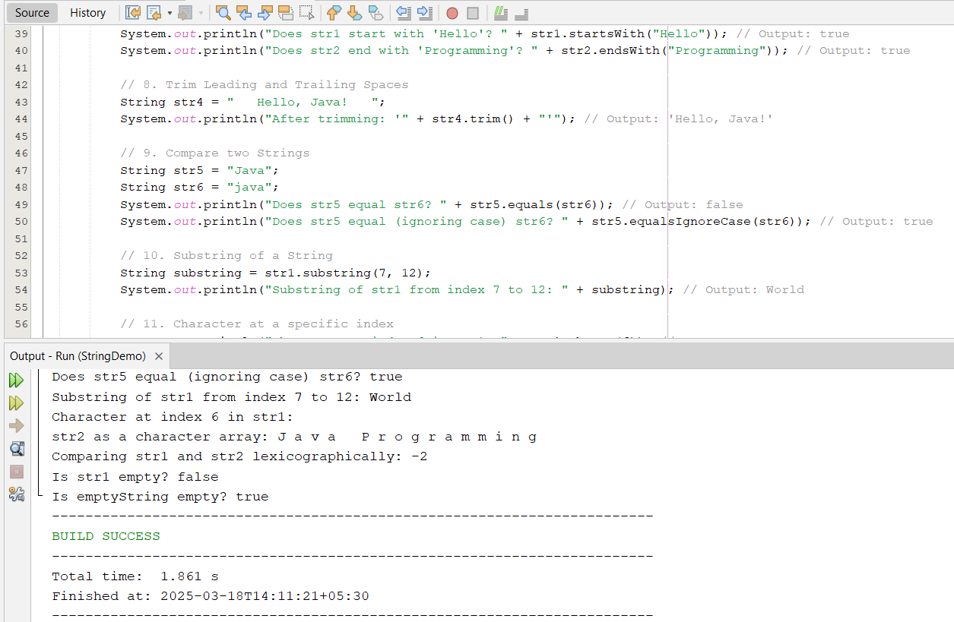

PRACTICAL-19
Implement single-level inheritance, Multi-level inheritance, Hierarchical Inheritance and Hybrid Inheritance

- single-level inheritance // Parent class
class Animal {
void sound() {
System.out.println("Animals make sounds");
}
}

// Child class inherits from Animal
class Dog extends Animal {
void sound() {
System.out.println("Dog barks");
}
}
public class SingleLevelInheritance {
public static void main(String[] args) {
Dog dog = new Dog();
dog.sound(); // Output: Dog barks
}
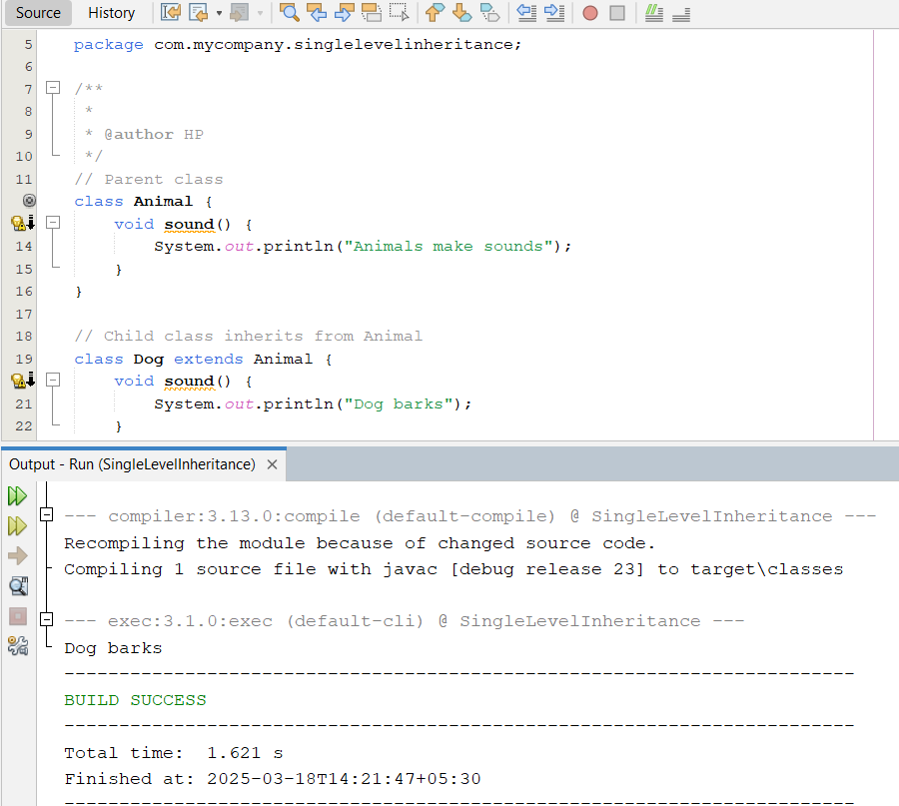
}
- Multi-level inheritance

// Grandparent class
class Animal {
void sound() {
System.out.println("Animals make sounds");
}
}
// Parent class inherits from Animal
class Mammal extends Animal {
void walk() {
System.out.println("Mammals walk");
}
}
// Child class inherits from Mammal
class Dog extends Mammal {
void sound() {
System.out.println("Dog barks");
}
}
public class MultiLevelInheritance {
public static void main(String[] args) {
Dog dog = new Dog();
dog.sound(); // Output: Dog barks
dog.walk(); // Output: Mammals walk
}
}

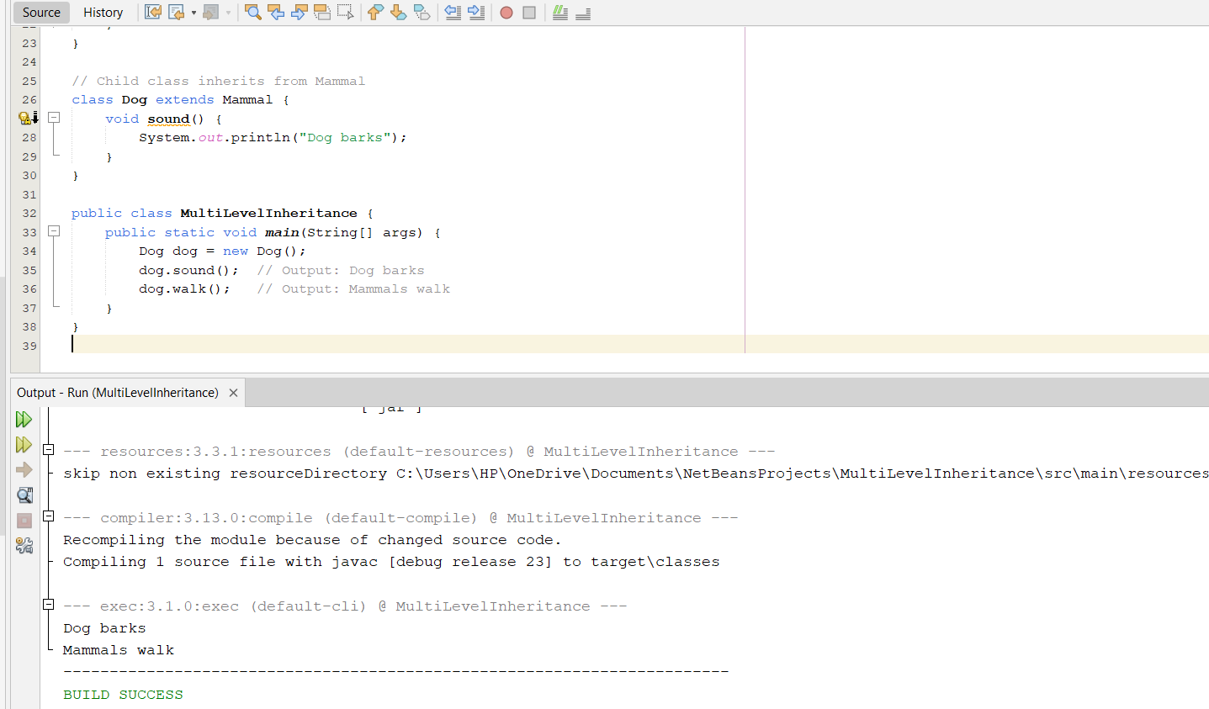

c. Hierarchical Inheritance

// Parent class
class Animal {
void sound() {
System.out.println("Animals make sounds");
}
}

// First child class inherits from Animal
class Dog extends Animal {
void sound() {
System.out.println("Dog barks");
}
}

// Second child class inherits from Animal
class Cat extends Animal {
void sound() {
System.out.println("Cat meows");
}
}

public class HierarchicalInheritance {
public static void main(String[] args) {
Dog dog = new Dog();
Cat cat = new Cat();

dog.sound(); // Output: Dog barks
cat.sound(); // Output: Cat meows
}
}
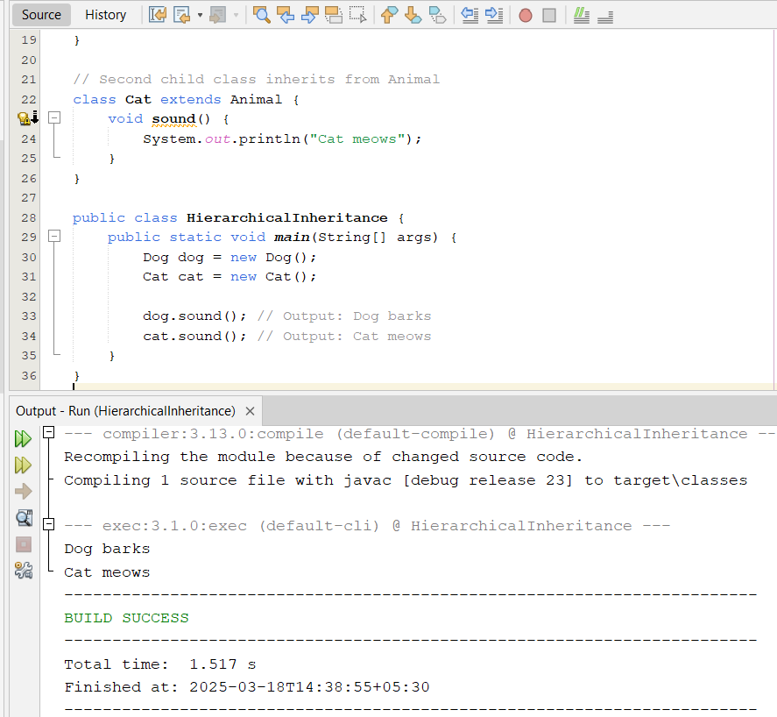

d. Hybrid Inheritance
// Interface 1
interface Animal {
void sound();
}
// Interface 2
interface Domestic {
void habitat();
}
// Child class implements both interfaces
class Dog implements Animal, Domestic {
public void sound() {
System.out.println("Dog barks");
}
public void habitat() {
System.out.println("Dogs live in homes");
}
}
public class HybridInheritance {
public static void main(String[] args) {
Dog dog = new Dog();
dog.sound(); // Output: Dog barks
dog.habitat(); // Output: Dogs live in homes




